Spring Boot MVC



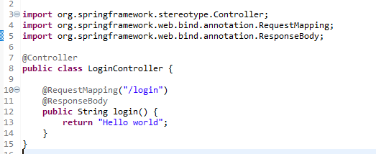

[**http://localhost:8080/login**](http://localhost:8080/login) **🡪 Hit this url**

**output:**

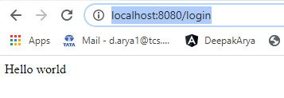

**Adding spring boot serurity:**

<dependency>

<groupId>org.springframework.boot</groupId>

<artifactId>spring-boot-starter-security</artifactId>

</dependency>

**http://localhost:8080/login**

[**http://localhost:8080/logout**](http://localhost:8080/logout)

**default password pring in logs**

**and username : user**

**create a home page and controller with test**